Creative Quilting With a Walking Foot

Instructor: Jacquie Gering
Email: jacquietps@gmail.com
Blog: www.tallgrassprairiestudio.blogspot.com

Website: www.jacquiegering.com

Class Description:
Want to quilt your quilts on your home machine and maybe free motion quilting isn't for you? Come discover the joy and creative possibilities of quilting with your walking foot. Linear quilting has a long history and is making a comeback in both modern and traditional quilts. Learn tips and tricks for successful quilting with your walking foot along with innovative quilting designs that can be accomplished on your home machine.
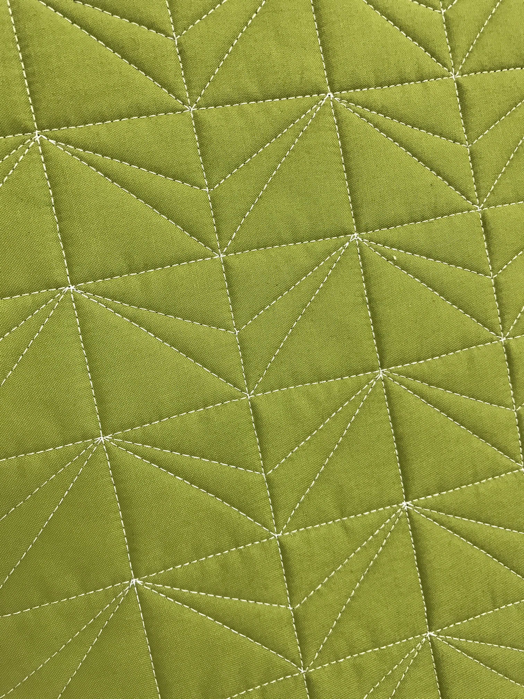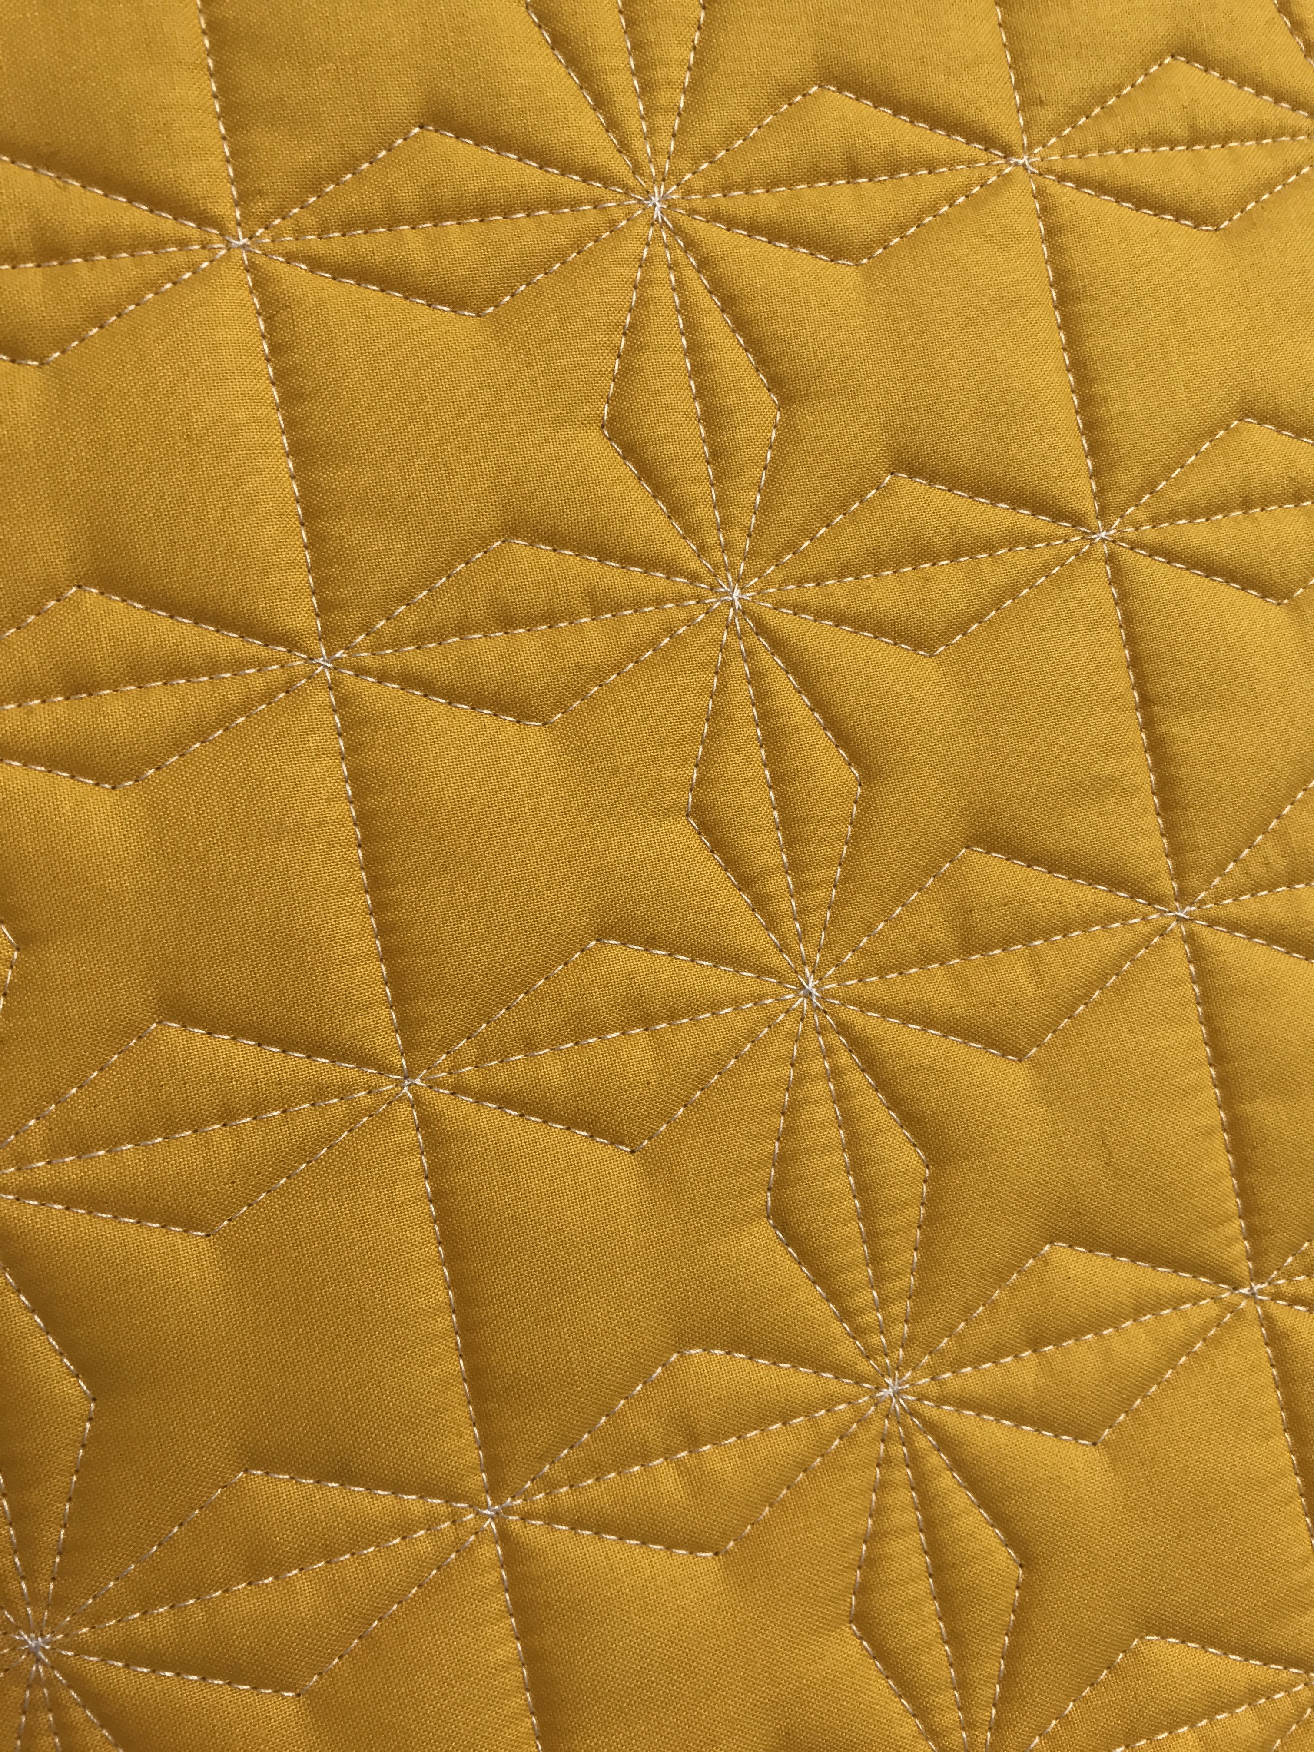

Materials List
Sewing machine with walking foot or dual feed. Please have the guide bar or seam guide that works with your walking foot. Please make sure your machine is clean, oiled and in good working order with a fresh needle installed.
An extension table is highly recommended, but not required. Please put on the open toe sole for your foot or use the dual feed foot with the most visibility around the needle. If you are using a dual feed, please have all the feet that work with the dual feed mechanism available and have all stitch plates that are available for your machine accessible for class.
Sewing machine manual
Knee lift if available
Extra sewing machine needles for quilting
Thread for quilting (I recommend 50 weight aurifil thread in both the top and bobbin) Thread that contrasts with your practice sandwiches will help you see your quilting stitches better while practicing.
Quilting gloves (optional)
Medium or fine point sharpie (This may be used to add markings to your walking foot if desired)
Hem gage or small ruler
Tweezers or stilletto
6" x 24" acrylic ruler
Fabric safe marker that contrasts with your samples

(1) 12" x 12" prepared quilt sandwich for practice (top, batting and backing)
(2) 12" x 18" prepared quilt sandwiches for practice (top, batting, and backing)
(2) 15" x 15" prepared quilt sandwiches for practice (top, batting, and backing)
Please make your sandwiches so that the backing and batting extends at least 1” on each side around the sample beyond the quiltable area.

Practice quilt sandwiches should be whole cloth and solid fabrics. I recommend low loft cotton batting. You can pin baste or spray baste your prepared quilt sandwiches but they need to be basted and ready to quilt. Spray basted quilt sandwiches will be easier to mark and are recommended.

If you have any questions about preparation, materials or equipment for the class, don't hesitate to contact me at jacquietps@gmail.com.

