Teeny Tiny Basket - Greeting Card

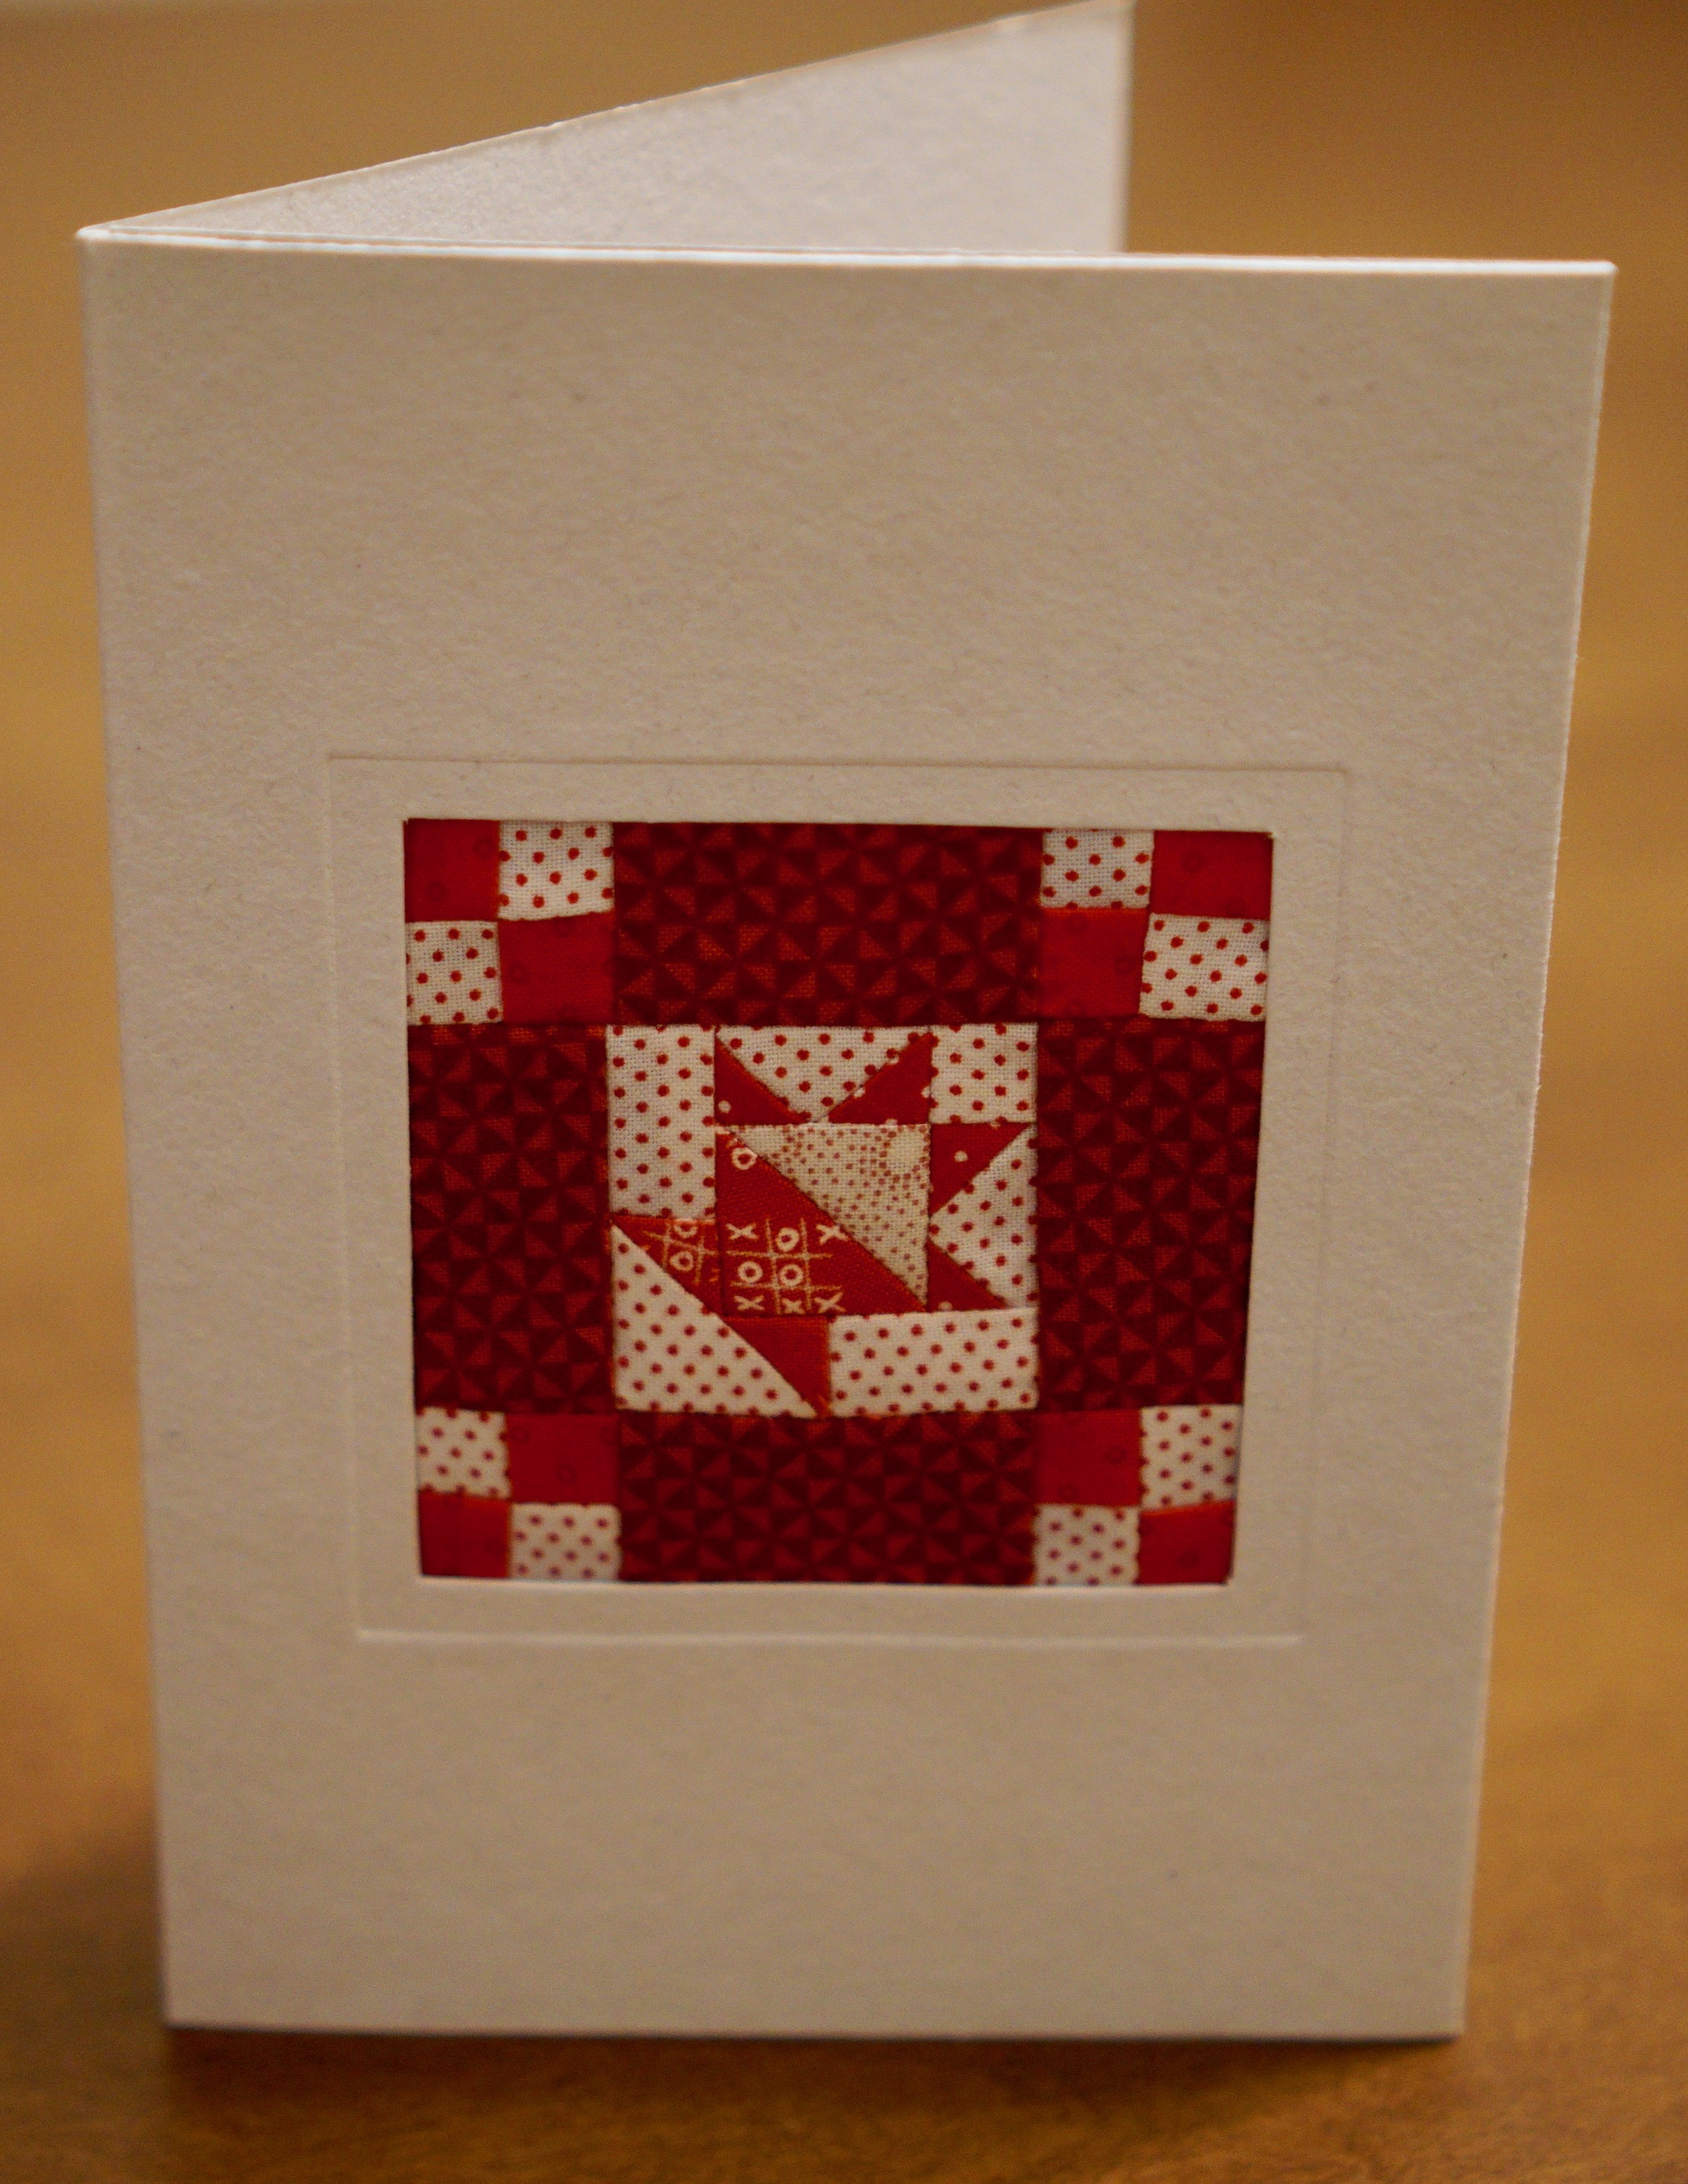
Class Description:

This class will teach you the fun of creating a miniature 3-1/2" x 3-1/2" quilt that can be used in the greeting card which is included in your pattern. Learn the simple secrets of small-scale piecing and leave with a finished masterpiece. Once you get hooked on making this tiny treasure, you may never make a large quilt again!

You will need to purchase the pattern which includes greeting card for $12.00 at the class.

Supply List:
Light and Dark fabric scraps
Or
6"x 6" square each of (4) different Red Fabrics
6"x 6" square each of (2) different White Fabrics
*Choose Fabric that is tone on tone and/or has a very small-scale print

- Thread for piecing
- 1/4" Foot for sewing machine
- #70 Sewing machine needles
- Marking Pencil
- Cutting Mat & Rotary Cutter
- Small Iron and Ironing pad
- X-ACTO Knife & cutting mat
- Small (6"x 6") ruler with 1/8" markings
- Longer Ruler for cutting strips with 1/8”” markings
- Stiletto or other pointed tool to control fabric
- All other items needed for sewing & quilting (scissors, seam ripper, etc.)

